SPRINT SARI 2024 - Monthly report - May

Update 2024-07-01

Table of Contents

Overall cohort 1

Stratified by pathogen type 4

This report covers the period from 01st May 2024 to 31st May 2024.

# Overall cohort

During the study period (01st May 2024 to 31st May 2024), there were **229** SARI patients admitted to a participating SPRINT-SARI ICU. The cumulative number of patients in the SPRINT-SARI recorded for the year 2024 (1st January to 31st May) is now **1002**. The weekly number of SARI admissions aggregated by calendar month is shown in **Figure 1**. Baseline characteristics of these patients are summarised in the **Table 1**.

|  |
| --- |
| **Figure 1.** Weekly SARI admissions |
|  |

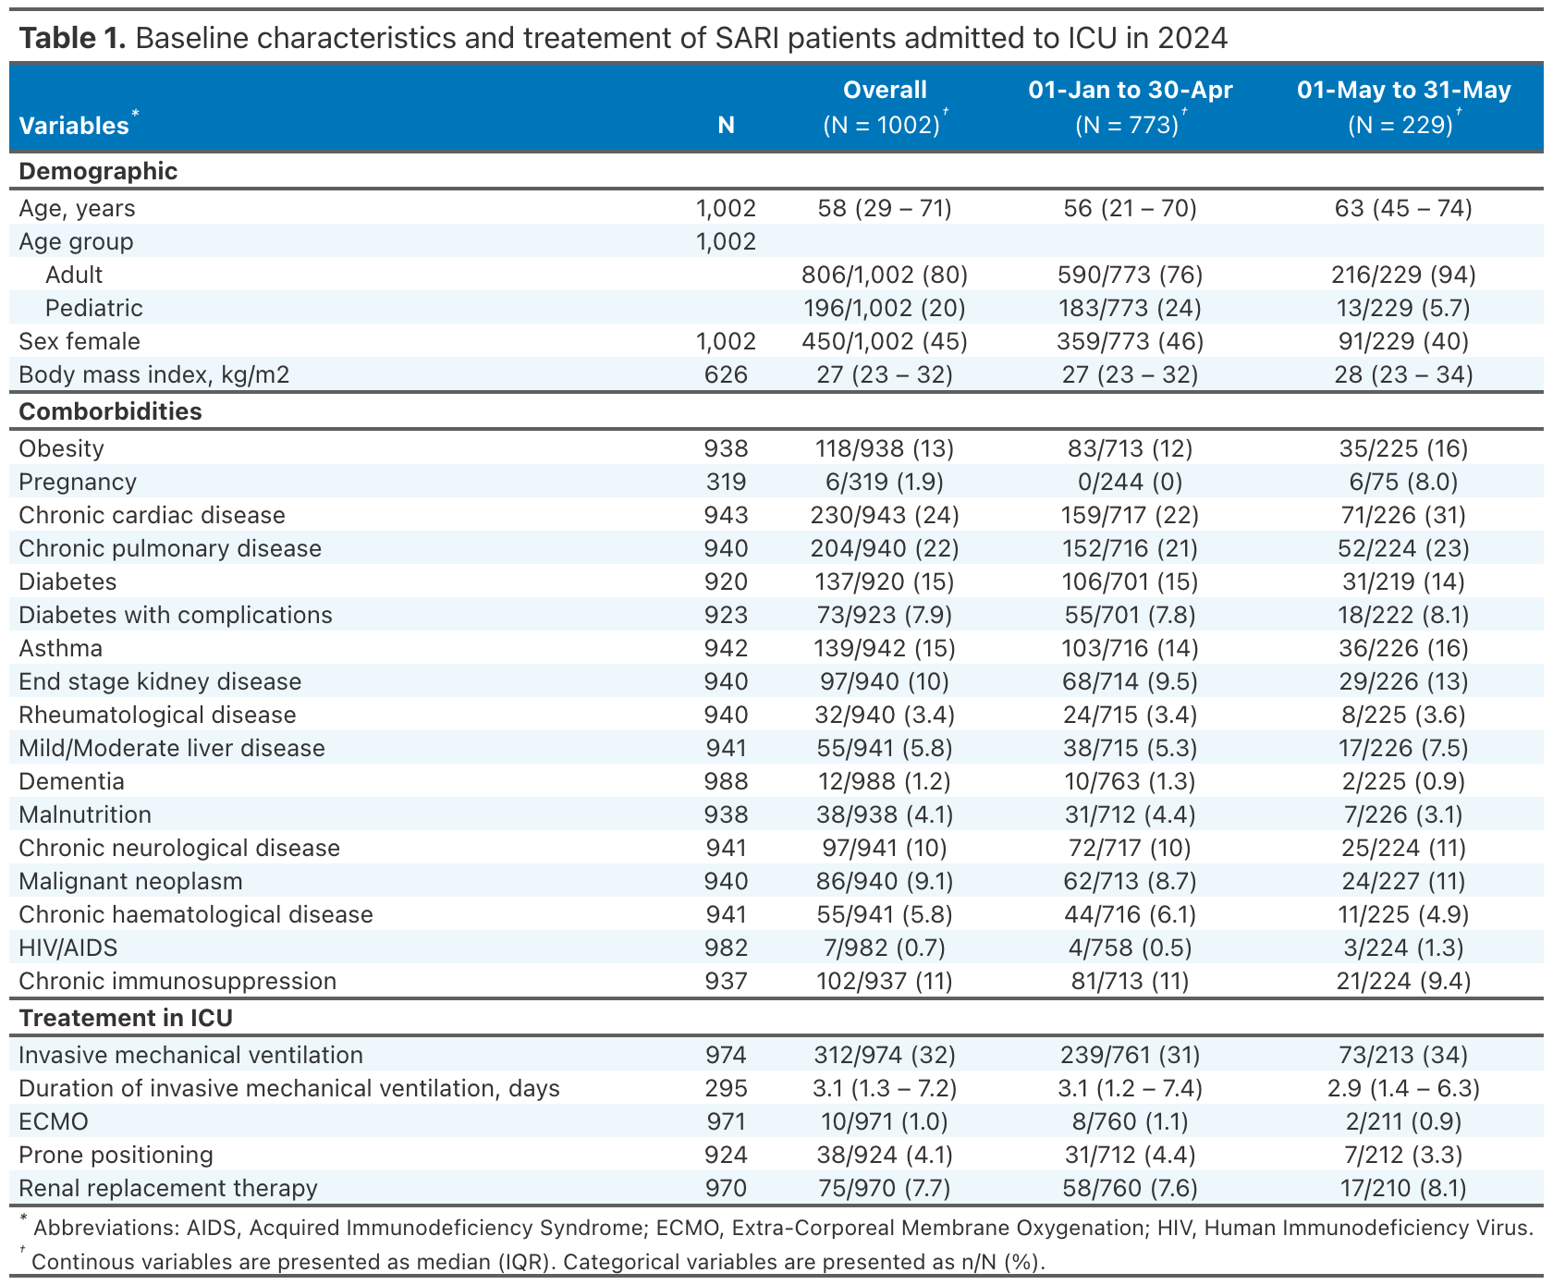

During the current study period 16/229 (7%) patients died in hospital, 169/229 (74%) were discharged to wards and 26/229 (11%) were still in hospital. The leading cause of death was treatment withdrawal 13/25 (52%) followed by hypoxic respiratory failure 5/25 (20%). The median length of stay in ICU and in hospital was 3 (2-5) and 8 (5-14) days, respectively. The outcomes of these patients are summarised in the **Table 2**.

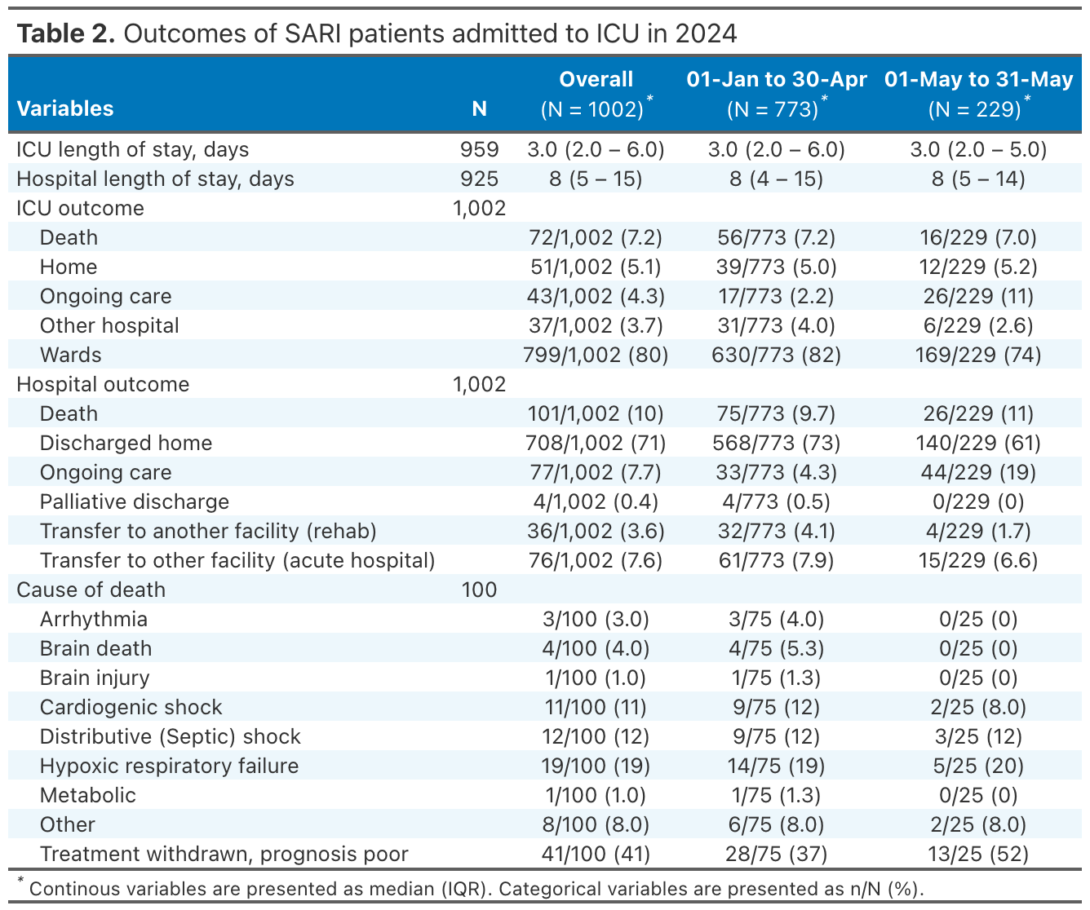

# Stratified by pathogen type

Overall 28 patients presented a viral co-infection. Categorization was performed as follows : COVID-19 > Influenza > RSV > Other. Baseline characteristics, intervention, and outcomes according to the pathogen type are presented in **Table 3** and **Table 4**. Weekly SARI admissions according to the pathogen type are displayed in **Figure 2**. A heatmap summarising all co-infection is displayed in **Figure 3**.

|  |
| --- |
| **Figure 2.** Weekly SARI admissions according to the pathogen type |
|  |

|  |
| --- |
| **Figure 3.** Heatmap of patients with viral co-infections |
|  |
| Each row represents a patient. Dark blue cells indicate a positive infection |

